Tagging of Smith & Van Dyck Arabic translation
with Strong’s Numbers

Contents
1 Introduction 2
2 Viewing the Arabic tagged Bible on StepBible.Org 3
2.1 The quick lexicon 3
2.2 Word Analysis 3
2.3 The Interleaved mode 4
2.4 The Interlinear mode 5
3 Viewing the Arabic tagged Bible on ABOM Injeel Website 6
4 Translation Tags 9
4.1 Old Testament 9
4.1.1 Using the Septuagint to fill in words missing from the Masoretic text 9
4.1.2 Differences in verse numbering between The Arabic translation and the MT 10
4.2 New Testament 11
4.2.1 Mapping Arabic to a relatively complex Greek syntax structure 11
4.2.2 Example of a word from a previous verse 12
5 Acknowledgement 13
5.1 TAHOT - Translators Amalgamated Hebrew OT 13
5.2 TAGNT - Translators Amalgamated Greek NT in Sheets or data 13
6 References 14

Introduction
The purpose of this document is to give a brief introduction to the tagged Smith & Van Dyck translation. The tagging process attaches a Strong’s Number to almost each word in the text. In using the tagged text to compare it to a text in the original language, or to other translations (as demonstrated in the examples in this document), one may observe some differences. Therefore, the purpose of this introduction is to explain very briefly the challenges met during the tagging process, and not to give an comment of the translation itself.
For me, it is almost certain that Dr. Smith and Dr. Van Dyck et al, used the Masoretic Text (maybe the Leningrad Codex) for the Old Testament translation. This made it easy to tag the OT Arabic text with Strong’s numbers. However, it is not clear to me, which Greek Manuscripts were used. According to various references Dr. Eli Smith preferred an eclectic approach. “His text was August Hahn's recension of the Greek, and he adopted various readings from Alford and from Tregelles”. When Dr. Van Dyck was appointed to take over the work, the American Bible Society required adherence to the Textus Receptus of Hahn’s Greek Testament. However, According to Dr. Van Dyck, he used the Textus Receptus of John Mills.
In the tagging process, it was noted that, in general, the Arabic translation of the New Testament followed a Textus Receptus close to that of KJV. However, there are also many variations in the translation that makes it track the Greek closely. This actually reflects how thorough and meticulous Dr. Van Dyck was, but also represented some challenges in the tagging process.
To illustrate the point about the New Testament translation, in the following examples table, Nestle-Aland Greek Text is used to represent a variant Greek text. Nestle-Aland was not available to Dr. Van Dyck et al, but the MSS used for it, could’ve been.
 | Reference | SVD | SVD Tag | KJV | Textus Receptus | Nestle-Aland
1 | Mat 1:10 | آمُون | G0300 | Amon | Αμων (آمُون) / G0300 | Αμως (آمُوص أو عَامُوس ) / G0301
2 | Gal 1:18 | بُطْرُسَ | G4074 | Peter | πετρον (بُطْرُسَ) / G4074 | Κηφαν (صَفَا) / Κηφαν
3 | John 18:30 | فَاعِلَ شَرّ | فَاعِلَ = G4160  شَرّ = G2556 | malefactor | κακοποιός / G2555 | κακον ποιων  κακὸν (شَرّ) / G2556  ποιῶν (فَاعِلَ ) / G4160
4 | Act 16:17 | (يُنَادُونَ) لَكُمْ | G4771 | unto us | ημιν (لنا) / G2249 | υμιν (لكم) / G4771
5 | Act 17:27 | اللهَ | G2316 | the Lord | τον κυριον (الرب) / G2962G | τον θεον (الله) / G2316
6 | Php 4:3 | نَعَمْ | G3483 | And | και (و) / G2532 | ναὶ (نَعَمْ) / G3483
Rows 1 and 2 are representative of the Smith & Van Dyck translation following the Textus Receptus, matching KJV (as compared to modern translations following Nestle-Aland).
Row 3 represents a tagging choice. Since the single Greek word in TR translates to two Arabic words. Dr. Van Dyck may have translated it from the TR into the two words. However, since Nestle’s text has the two words explicitly stated, it was clearer to use it for tagging.
Rows 4, 5 and 6 are examples of definite deviation from TR and KJV, therefore, Nestle’s text was used for tagging.
“The results of tagging demonstrate that Smith & Van Dyck Arabic Bible is closer aligned to the OT text than almost any other modern translation. Its strict translation policy for the NT also enables it to track the Greek closely. This Arabic tagged Bible is therefore a very useful modern tool for studying the original text without knowing all the nuances of ancient Hebrew and Greek.” (Rev Dr David Instone Brewer)

Viewing the Arabic tagged Bible on StepBible.Org
StepBible.Org is an excellent resource to study the SVD tagged Arabic Bible. The following is a very brief introduction to using it.
This link displays chapter 6 of Hebrews for which a partial screenshot is shown below
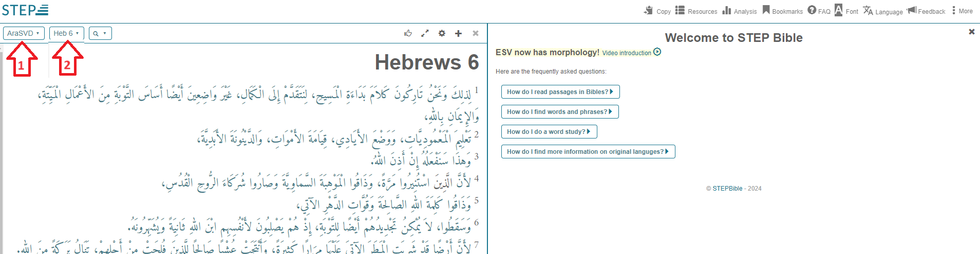
Figure 1
The right panel contains answers to many Frequently Asked Question. It may be closed by clicking the “x” at its top right corner. You can get it back by clicking the FAQ menu at the top, and use it to get acquainted with STEP Bible.
The button 2 above is the “passage selection” button, where you can select a chapter of a specific book or type in a passage reference e.g. Rev 21 or more than one reference e.g. John 3:16, Rom 3:23 or a range e.g. Heb 6:4-7.

The quick lexicon
As you hover with the mouse pointers over the words, a Quick Lexicon appears, showing the original language word, its meaning, transliteration and a brief description (currently the quick lexicon is being translated into Arabic and should be available in the near future).

Word Analysis
Clicking the word will show its word analysis in the right panel. Following is a partial screenshot showing both the Quick Lexicon at the top, and word analysis for “التَّوْبَةِ”.
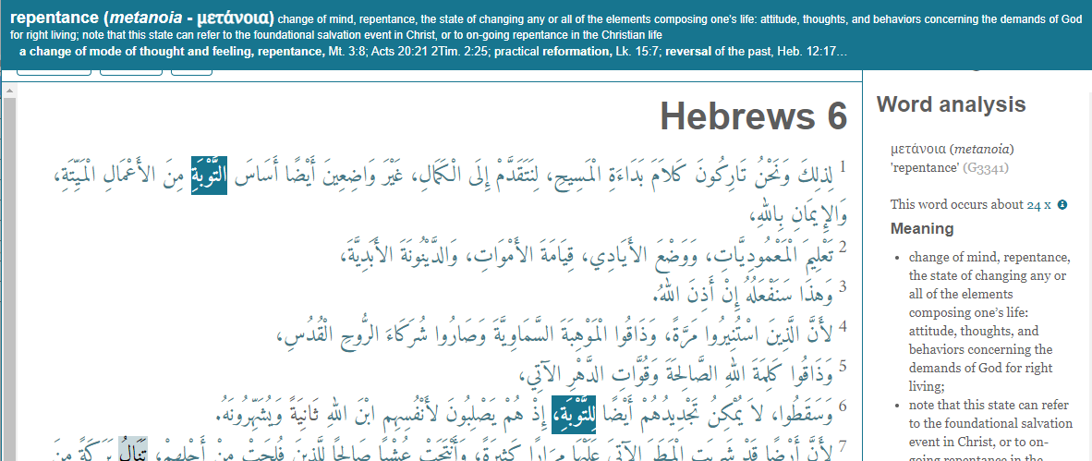
Figure 2

The Interleaved mode
The Bible button (button 1 in Figure 1) allows you to select multiple Bibles for comparison. As an example, we will select the following Bibles:
- SVD - Arabic Bible.
- THGNT - Tyndale House Greek New Testament.
- TR - Stephens 1550 & Scrivener 1894 Textus Receptus.
- ESV - English Standard Version (ESV)”.
- KJV - King James Version
We will also use the Passage Selection button (button 2 in Figure 1) to select three of the verses mentioned in the introduction: Gal 1:18, John 18:30 and Act 17:27. The default display mode is the “Interleaved” as shown in the screen shot below. To see it on the actual page, click here.
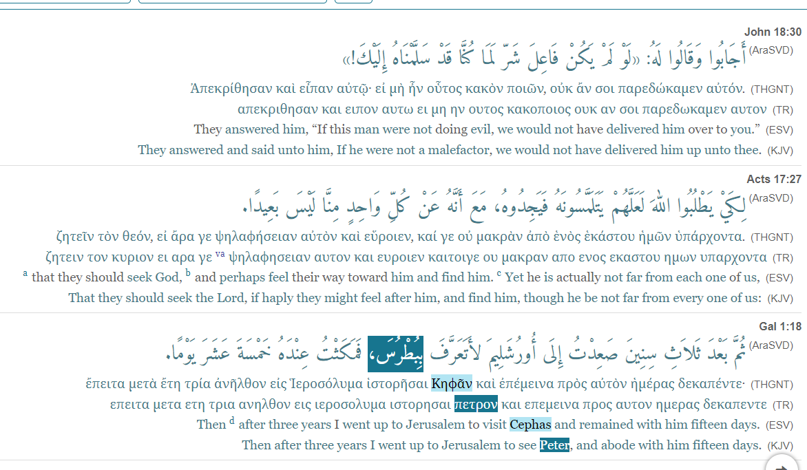
In the above, clicking the word “بِبُطْرُسَ” ln Gal 1:1 shows the corresponding Greek in both THGNT and TR. The darker highlighting in the TR, indicates an exact match while the lighter highlighting indicates a related word. It also shows how the word was translated in KJV and in ESV.

The Interlinear mode
For this mode our example is 1Co 13:4-7. We exclude THGNT to mange the size of the screencapture.
From the options menu we select Interlinear
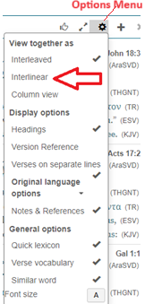
The result (which is actually a reverse interlinear) is shown in the following screenshot. The actual page can be seen here.
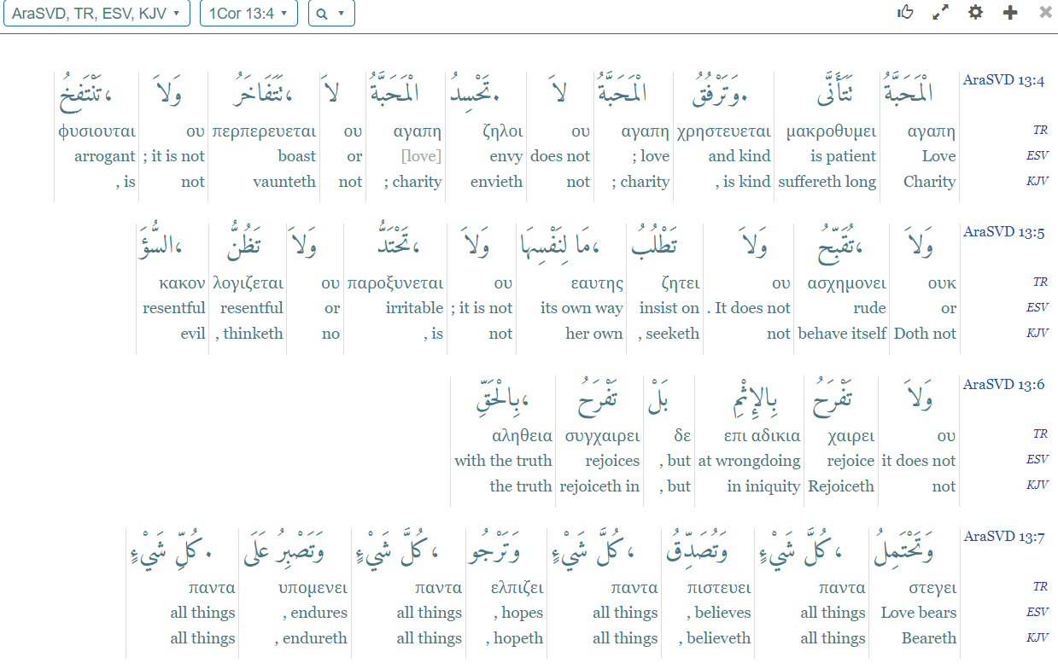

Viewing the Arabic tagged Bible on ABOM Injeel Website
The Arabic Bible Outreach Ministries’ site: الكتاب المقدس (injeel.com) is another excellent resource to study the SVD tagged Arabic Bible. The site is very easy to navigate.
From the main page, click “قراءة”
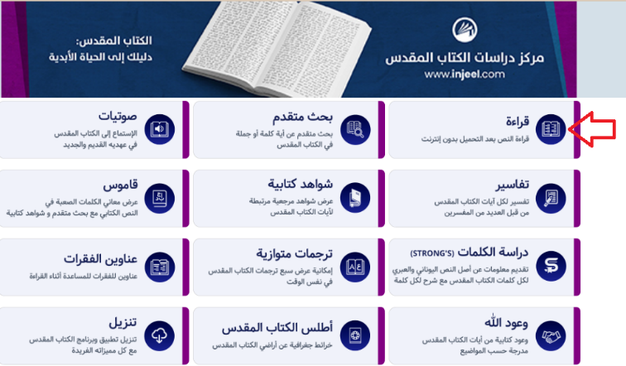
On the Bible reading page, select a book and chapter. In the following screenshot, we selected Psalm 8.
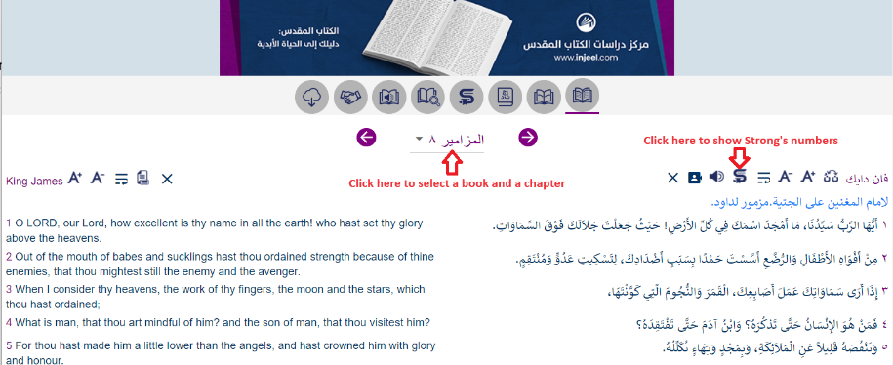
By clicking the icon, Strong's numbers associated with the words of the verse appear as in the following screenshot.
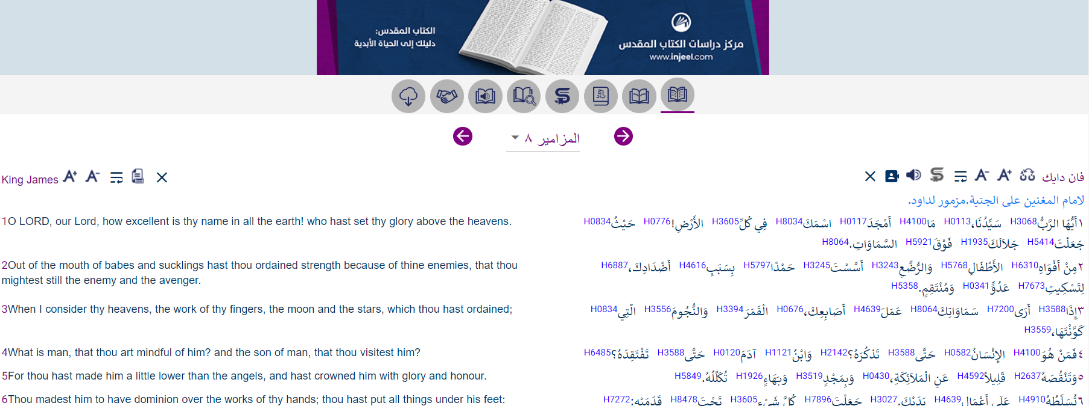
We can now study the words of the verse in the original language by clicking Strong's numbers. For example, the following screenshot was created by clicking H0430 next to the word "الْمَلاَئِكَةِ" in verse 5.
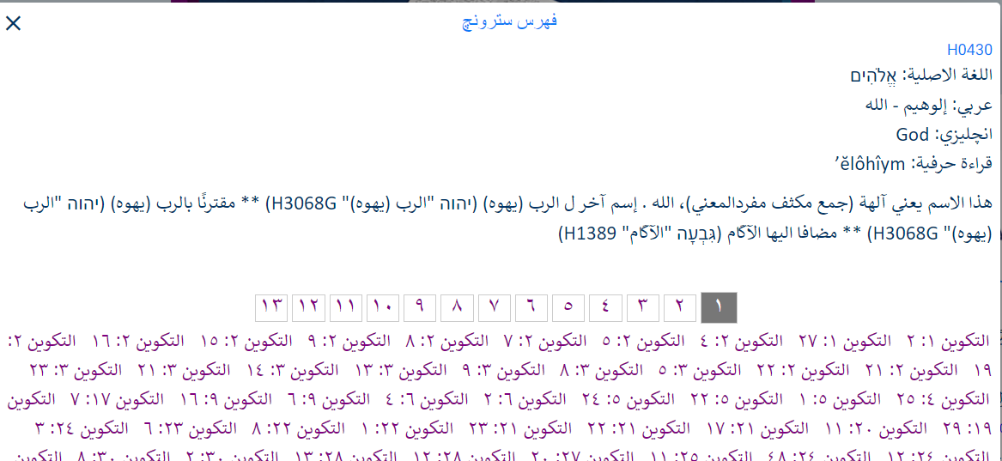
You can also click on any word in a verse, to study that verse in more depth. For example, the following screenshot was created by clicking a word in the first verse. It shows a list of four options. You can click on the different options to get acquitted with the site.

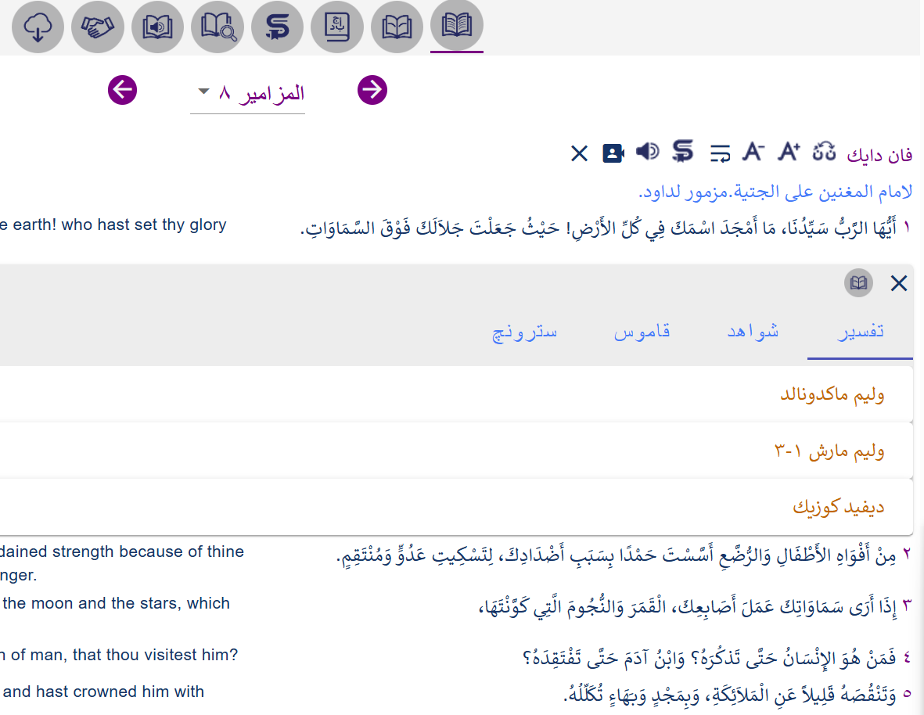
To view Strong’s numbers for each word in the verse, click “سترونچ”.
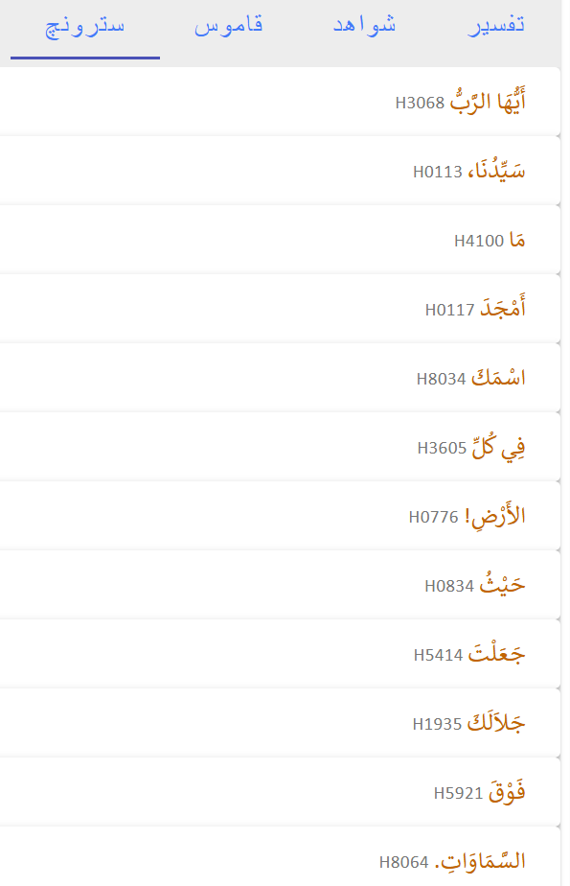

You can now click any of the words to see more details. For example, we clicked on the word “جَلاَلَكَ” to get the following:
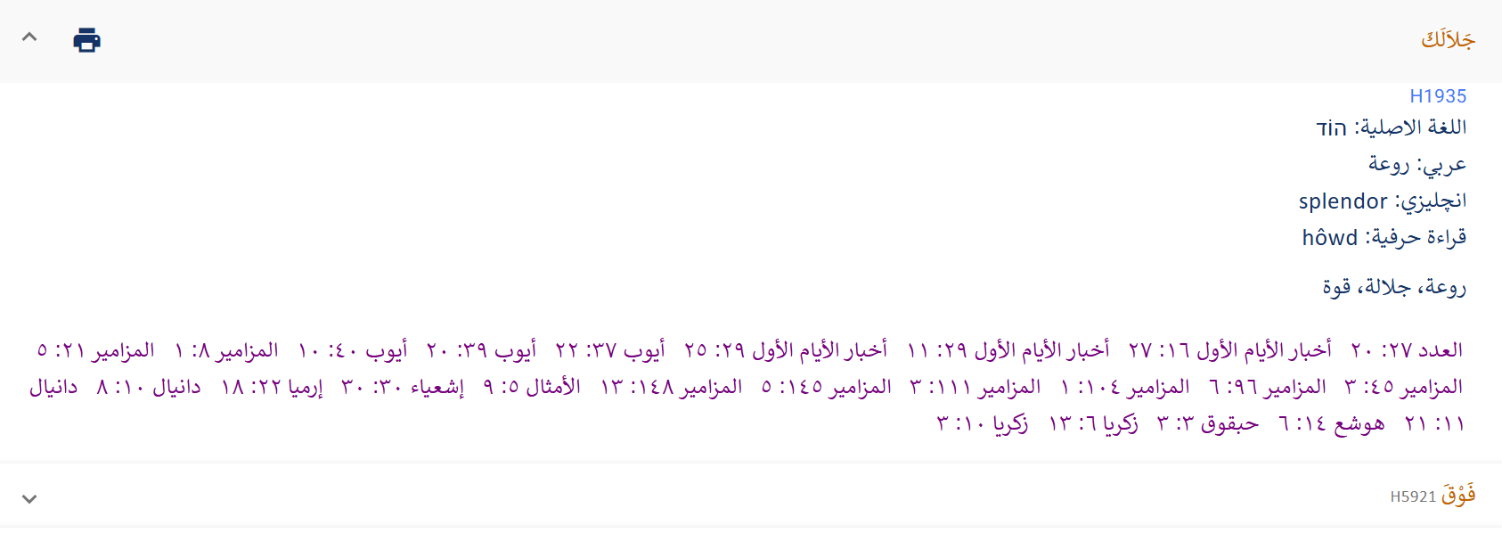
You can further click any of the listed reference to see how the same Hebrew word is used. As an example, we clicked “إشعياء ۳۰: ۳۰” to get the following:
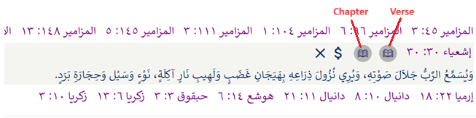
You can drill further down by clicking the verse icon or the chapter icon.

Translation Tags
Translation tags are very similar to the tagged Bible, except that it provides more details about the underlying original language. There is a single file for each of the Old Testament and the New Testament. There is also individual files for each book of the Bible. The files are in a tab separated format which can be easily viewed with a spread sheet program like MS Excel or Google Sheets. The files are located here.

Old Testament
For Hebrew, it shows the Hebrew word (from the Masoretic Text - MT), its Strong’s number, grammar, English transliteration, English meaning, and the word number in the corresponding Masoretic Hebrew verse. The word number specifically is not reflected in the tagged Bible described above. The word number is important for various reasons as shown below:

Using the Septuagint to fill in words missing from the Masoretic text
Num 26:40
The translation tags shows that the sixth word "لأرد" is missing from the Masoretic Text, but present in the Septuagint.
Ara W# | Arabic | Strongs | Grammar | Heb w# | Hebrew | Transliteration | Word-by-word
#01 | وكان | H9001/{H1961} | Hc/Vqw3mp | #01 | וַ יִּהְי֥וּ | va/i.yih.Yu | and/ they were
#02 | ابنا | {H1121G}\H9014 | HNcmpc | #02 | בְנֵי | ve.nei- | [the] descendants of
#03 | بالع: | {H1106A} | HNpm | #03 | בֶ֖לַע | Ve.la' | Bela
#04 | أرد | {H0714H} | HNpm | #04 | אַ֣רְדְּ | 'ard | Ard
#05 | ونعمان. | H9002/{H5283H} | HC/Npm | #05 | וְ נַעֲמָ֑ן | ve./na.'a.Man | and/ Naaman
#06 | لأرد | H9005/{H0714H} | HR/Npm | #0501X | לְ אַרְדְּ | le./'ard | to/ Ard
#07 | عشيرة | {H4940} | HNcfsc | #06 | מִשְׁפַּ֙חַת֙ | mish.Pa.chat | [the] clan of
#08 | الأرديين، | H9009/{H0716} | HTd/Ngmsa | #07 | הָֽ אַרְדִּ֔י | ha./'ar.Di | the/ Ardite[s]
#09 | ولنعمان | H9005/{H5283H} | HR/Npm | #08 | לְ נַֽעֲמָ֔ן | le./na.'a.Man | to/ Naaman
#10 | عشيرة | {H4940} | HNcfsc | #09 | מִשְׁפַּ֖חַת | mish.Pa.chat | [the] clan of
#11 | النعمانيين. | H9009/{H5280}\H9016 | HTd/Ngmsa | #10 | הַֽ נַּעֲמִֽי | Ha./na.'a.Mi | the/ Naamanite[s]
Under the “Heb w#”, #0501 X indicates that this is the first word inserted after the fifth word in the MT. The X indicates that the source is the Septuagint (LXX).
The following image shows the missing word in the MT.
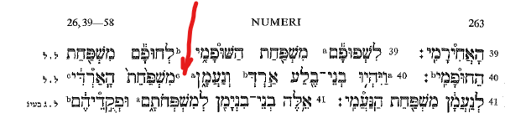

Differences in verse numbering between The Arabic translation and the MT
Psa 3:1
Because the Psalm title in the MT is considered verse 1. Therefore Arabic verse 1 (starting at word 9 below) corresponds to Verse 2 in the MT.
Ara W# | Arabic | Strongs | Grammar | Heb w# | Hebrew | Transliteration | Word-by-word
#01 | مَزْمُورٌ | {H4210} | HNcmsa | #01 | מִזְמ֥וֹר | miz.Mor | a psalm
#02 | لِدَاوُدَ | H9005/{H1732} | HR/Npm | #02 | לְ דָוִ֑ד | le./da.Vid | of/ David
#03 - #04 | حِينَمَا هَرَبَ | H9003/{H1272}/H9043 | HR/Vqcc/Sp3ms | #03 | בְּ֝ בָרְח֗ וֹ | be./va.re.Ch/o | when/ fled/ he
#05 - #06 | مِنْ وَجْهِ | H9006/{H6440G}\H9015 | HR/Ncmpc | #04 | מִ פְּנֵ֤י | mi./pe.Nei | from/ before
#07 | أَبْشَالُومَ | {H0053} | HNpm | #05 | אַבְשָׁל֬וֹם | 'av.sha.Lom | Absalom
#08 | ابْنِهِ | {H1121A}/H9023\H9016 | HNcmsc/Sp3ms | #06 | בְּנֽ וֹ | be.N/o | son/ his
#09 - #10 | يَا رَبُّ، | {H3068G} | HNpt | (3.2)#01 | יְ֭הוָה | Yah.weh | O Yahweh
#11 | مَا | {H4100}\H9014 | HPi | (3.2)#02 | מָֽה | mah- | how.
#12 | أَكْثَرَ | {H7231} | HVqp3cp | (3.2)#03 | רַבּ֣וּ | ra.Bu | they are many
#13 | مُضَايِقِيَّ. | {H6862C}/H9020 | HNcmpc/Sp1bs | (3.2)#04 | צָרָ֑ י | tza.Ra/i | opponents/ my
#14 | كَثِيرُونَ | {H7227A} | HAampa | (3.2)#05 | רַ֝בִּ֗ים | ra.Bim | many [people]
#15 | قَائِمُونَ | {H6965J} | HVqrmpa | (3.2)#06 | קָמִ֥ים | ka.Mim | [are] rising up
#16 | عَلَيَّ. | {H5921A}/H9030\H9016 | HR/Sp1bs | (3.2)#07 | עָלָֽ י | 'a.La/i | on/ me

New Testament
To avoid clutter, in the tagged Bible described above, many of the Greek particles are not tagged, unless they stand alone. The translation tags, includes all the particles. This makes it a good tool to understand the underlying Greek text.

Mapping Arabic to a relatively complex Greek syntax structure
In this example observe the Greek word order under “Grk w#”.
Heb 1:6
Ara W# | Arabic | Strongs | Greek | Lexicon | Gloss | Transliteration | Grammar | Grk w#
#01 | لِذلِكَ | G1352 | Διὸ | διό | for | Dio | CONJ | #01NKO
#02 - #03 | وَنَحْنُ تَارِكُونَ | G0863G | ἀφέντες | ἀφίημι | to release | aphentes | V-2AAP-NPM | #02NKO
#04 | كَلاَمَ | G3588; G3056 | τὸν ; λόγον | ὁ; λόγος | the/this/who; word | ton; logon | T-ASM; N-ASM | #03NKO; #08NKO
#05 | بَدَاءَةِ | G3588; G0746 | τῆς ; ἀρχῆς | ὁ; ἀρχή | the/this/who; beginning | tēs; archēs | T-GSF; N-GSF | #04NKO; #05NKO
#06 | الْمَسِيحِ، | G3588; G5547 | τοῦ ; Χριστοῦ | ὁ; Χριστός | the/this/who; Christ | tou; Christou | T-GSM; N-GSM-T | #06NKO; #07NKO
#07 | لِنَتَقَدَّمْ | G5342 | φερώμεθα | φέρω | to bear/lead | pherōmetha | V-PPS-1P | #12NKO
#08 | إِلَى | G1909 | ἐπὶ | ἐπί | upon/to/against | epi | PREP | #09NKO
#09 | الْكَمَالِ، | G3588; G5047 | τὴν ; τελειότητα | ὁ; τελειότης | the/this/who; perfection | tēn; teleiotēta | T-ASF; N-ASF | #10NKO; #11NKO
#10 | غَيْرَ | G3361 | μὴ | μή | not | mē | PRT-N | #13NKO
#11 | وَاضِعِينَ | G2598 | καταβαλλόμενοι | καταβάλλω | to lay/throw down | kataballomenoi | V-PEP-NPM | #16NKO
#12 | أَيْضًا | G3825 | πάλιν | πάλιν | again | palin | ADV | #14NKO
#13 | أَسَاسَ | G2310 | θεμέλιον | θεμέλιος | foundation | themelion | N-ASM | #15NKO
#14 | التَّوْبَةِ | G3341 | μετανοίας | μετάνοια | repentance | metanoias | N-GSF | #17NKO
#15 | مِنَ | G0575 | ἀπὸ | ἀπό | away from | apo | PREP | #18NKO
#16 | الأَعْمَالِ | G2041 | ἔργων | ἔργον | work | ergōn | N-GPN | #20NKO
#17 | الْمَيِّتَةِ، | G3498 | νεκρῶν | νεκρός | dead | nekrōn | A-GPN | #19NKO
#18 | وَالإِيمَانِ | G2532; G4102G | καὶ ; πίστεως | καί; πίστις | and; faith | kai; pisteōs | CONJ; N-GSF | #21NKO; #22NKO
#19 | بِاللهِ، | G1909; G2316 | ἐπὶ ; θεόν, | ἐπί; θεός | upon/to/against; God | epi; theon | PREP; N-ASM-T | #23NKO; #24NKO

Example of a word from a previous verse
In this example, words 2 & 3 of Heb 6:6 “لاَ يُمْكِنُ”, is not actually in the Greek verse 6, but is a translation of the first word of the Greek Heb 6:4 as shown under “Grk w#”: (6.4)#01
Heb 6:6
Ara W# | Arabic | Strongs | Greek | Lexicon | Gloss | Transliteration | Grammar | Grk w#
#01 | وَسَقَطُوا، | G2532; G3895 | καὶ ; παραπεσόντας | καί; παραπίπτω | and; to defect | kai; parapesontas | CONJ; V-2AAP-APM | #01NKO; #02NKO
#02 - #03 | لاَ يُمْكِنُ | G0102 | ἀδύνατον | ἀδύνατος | unable | adunaton | A-NSN | (6.4)#01NKO
#04 | تَجْدِيدُهُمْ | G0340 | ἀνακαινίζειν | ἀνακαινίζω | to restore | anakainizein | V-PAN | #04NKO
#05 | أَيْضًا | G3825 | πάλιν | πάλιν | again | palin | ADV | #03NKO
#06 | لِلتَّوْبَةِ، | G1519; G3341 | εἰς ; μετάνοιαν | εἰς; μετάνοια | toward; repentance | eis; metanoian | PREP; N-ASF | #05NKO; #06NKO
#07 - #09 | إِذْ هُمْ يَصْلِبُونَ | G0388 | ἀνασταυροῦντας | ἀνασταυρόω | to recrucify | anastaurountas | V-PAP-APM | #07NKO
#10 | لأَنْفُسِهِم | G1438 | ἑαυτοῖς | ἑαυτοῦ | my/your/him-self | he'autois | F-3DPM | #08NKO
#11 | ابْنَ | G3588; G5207 | τὸν ; υἱὸν | ὁ; υἱός | the/this/who; son | ton; huion | T-ASM; N-ASM | #09NKO; #10NKO
#12 | اللهِ | G3588; G2316 | τοῦ ; θεοῦ | ὁ; θεός | the/this/who; God | tou; theou | T-GSM; N-GSM-T | #11NKO; #12NKO
#13 | ثَانِيَةً
#14 | وَيُشَهِّرُونَهُ. | G2532; G3856 | καὶ ; παραδειγματίζοντας. | καί; παραδειγματίζω | and; to disgrace | kai; paradeigmatizontas | CONJ; V-PAP-APM | #13NKO; #14NKO

In the above verse, words 7,8 and 9 is a translation of a Greek word that means re-crucify. Therefore, the Arabic translation of the word could’ve been إِذْ هُمْ يَصْلِبُونَ ثَانِيَةً. But because of the Arabic sentence style, the word ثَانِيَةً was shifted towards the end, and therefore did not have a Strong’s number of its own.

Acknowledgement
Tagging of the Smith and Van Dyck translation was made possible through the kind permission of the Arabic Bible Outreach Ministry to use their Arabic text and to make the resulting tagged Bible available publicly under CC BY-SA 4.0. For the actual tagging process, I am indebted to Rev Dr David Instone Brewer for his patience and invaluable guidance.
Strong’s numbers and related information were obtained from STEP Bible’s Data Sets available under STEPBible-Data/Translators Amalgamated OT+NT at master · STEPBible/STEPBible-Data (github.com). This data set consists of TAHOT - Translators Amalgamated Hebrew OT and TAGNT - Translators Amalgamated Greek NT in Sheets or data.

TAHOT - Translators Amalgamated Hebrew OT
The Leningrad codex based on Westminster via OpenScriptures, corrected from colour scans, with full morphological and semantic tags for all words, prefixes and suffixes. Semantic tags using the disambiguated Strongs is backwardly compatible with simple Strongs tags and includes all affixes (as defined in TBESH). Morphology is based on ETCBC converted to the format of OS (similar to Westminster) with different morphology for Ketiv/Qere when needed. LXX additions included as Hebrew from BHS/BHK apparatus.

TAGNT - Translators Amalgamated Greek NT in Sheets or data
Greek text that includes all the words in NA27/28, TR and other major editions (SBLGNT, Treg, Byz, WH, THGNT). Each word is marked with the editions that contain it, positional variants, and meaning variants. All words and meaning variants are tagged lexically (disambiguated Strong linked to LSJ) and morphologically (Robinson based on Tauber with missing details) plus context-sensitive translations Punctuation is based on THGNT with spellings from NA28 or other editions for words not in NA27/28.

Sami Onsy Abdel Malik
sami.abdelmalik@gmail.com

References
- Brief Documentary of the Translation of the Scriptures into the Arabic Language; American Presbyterian Mission Press, 1900. (Brief documentary history of the translation of the Scriptures into the Arabic language : Presbyterian Church in the U.S.A. Syria Mission : Free Download, Borrow, and Streaming : Internet Archive)
- The Greek Texts of Eli Smith and Cornelius Van Dyck, Joshua Yoder (joshua@etsc.org) Evangelical Theological Seminary in Cairo. (Cairo-Journal-of-Theology-2-2015-Yoder.pdf (etsc.org))
- The Arabic Bible of Drs. Eli Smith and Cornelius V.A. Vandyck, Isaac H. Hall, Journal of the American Oriental Society, 1885, Vol. 11 (1885), pp. 276-286 (https://www.jstor.org/stable/592194 )
- The Major Arabic Bibles, Their Origin and Nature. John Alexander Thompson, Evangelical Theological Seminary, Cairo, Egypt. Published by AMERICAN BIBLE SOCIETY, NEW YORK 1956. (https://archive.org/details/majorarabicbible00thom )
- Fifty Three Years In Syria Volume I, Henry Harris Jessup (1832–1910), Fleming H. Revell Company, 1910 (https://archive.org/details/in.ernet.dli.2015.90302/page/n9/mode/2up )
- Textual Criticism, Introduction, (English Guide to the Various Readings of the Greek New Testament (bible-researcher.com))
- An Introduction to the Textual Criticism of the New Testament, A. T. Robertson, Nashville: Broadman, 1925 (An Introduction to the Textual Criticism of the New Testament : A.T Robertson : Free Download, Borrow, and Streaming : Internet Archive).

The known names to us are: Butrus al-Bustani, Nasif al-Yaziji and Yusuf al-Asir.
Page 22 of ref 4, and Ref 3.
Page 15 of ref 1. See also ref 2.
Page 74 of ref 4. Hahn’s Greek Testament is based on the text of Elzevir 1624.
Ref 3, end of page 282. Also ref 6: John Mill’s text is a combination of the texts of Stephens 1550, Elzevir 1624, and page 24 of ref 7.

